Frequently asked questions-
General public
National Standard for the Australian Builders Plate for Recreational Boats - Edition 5

These frequently asked questions (FAQs) are provided to assist with the understanding of the Australian Builders Plate Standard – Edition 5 (the Standard) as endorsed in June 2020 and its application.

No guarantees are provided for the accuracy or currency of information contained in this document, nor does it constitute legal advice. It remains the responsibility of a person calculating, fitting or otherwise interacting with an Australian Builders Plate (ABP) to ensure they comply with relevant legislation.
Contents

Definitions 1
FAQs - General public 2
The purpose of the ABP system 2
The ABP and the law 2
Implementation of the Standard 3
ABP location and fixing 6
Understanding the information on an ABP 6
ABP breakdown 8

Definitions

ABP – The Australian Builders Plate, which is affixed to recreational vessels as required by the National Standard for The Australian Builders Plate for Recreational Boats.

ABP Standard / the Standard / ABP Standard, Edition 5 (Edition 5) – The National Standard for The Australian Builders Plate for Recreational Boats endorsed by the Transport and Infrastructure Council on 5 June 2020, accessible here:
ABP Standard, Edition 4 (Edition 4) The National Standard for The Australian Builders Plate for Recreational Boats, published on 23 May, 2011 and superseded by Edition 5, accessible here:
ABYC – American Boat and Yacht Council.
ARBSC – The Australian Recreational Boating Safety Committee.
Boat builder – For the purposes of this document, reference to a ‘boat builder’ means a person who holds a responsibility to fix an ABP, unless otherwise specified.
CE – Conformité Européenne (certification marking).
Determining – The process of undertaking measurements, tests and calculations required to establish the information to be listed on an ABP.
HIN – Hull Identification Number.
NMMA – National Marine Manufacturers Association (United States).
Specified Standards / Specified Technical Standards – Documents that determine vessel build standards and associated calculations. These are the three referenced standards in the National Standard for The Australian Builders Plate for Recreational Boats. The specified standards referenced are the relevant Australian Standard (AS1799), American Boat and Yacht Council (ABYC) Standard and the International Organisation for Standardisation (ISO) Standards.

FAQs - General public

The purpose of the ABP system

What’s the purpose of the ABP?
The ABP system was introduced “in response to public demand for recreational boat safety and with the support of Australian boat builders”.

The Standard seeks to enhance the safety of persons on recreational boats by ensuring that certain boats are fitted with ABPs containing essential safety information applicable to that boat’s use. The Standard specifies that some of the displayed ABP information, such as maximum loading masses and flotation performance, are determined in compliance with specified technical standards. This aims to ensure that a boat has adequate volume and capacity to safely support the recommended loading and passenger masses listed on the ABP.

The Standard is also “a declaration by the builder or importer that the boat meets, to the extent specified within this Standard, the requirements of relevant national or international standards applicable to recreational boats”.

The ABP and the law

Is the ABP required by law?
All Australian states (and the Northern Territory) apply the ABP standard, either through maritime safety or consumer protection law. There are some differences between states in the enforcement mechanisms, resulting from difference in the way the local legislation was drafted. However; if somebody is trying to sell a new boat without an ABP, they may be in breach of the law and it may not be possible to register the boat.

When was the law introduced?
The Australian Builders Plate Standard was first published on 1 March 2005.

The law was introduced at different times in each state (and the NT). Local marine safety agencies can provide further information.

Implementation of the Standard

Which boats are required to have an ABP?
New powered recreational craft supplied in Australia, are required to have an ABP fitted unless subject to an exemption.

An ABP is not required on the following:
- aquatic toys
- amphibious vehicles
- canoes, kayaks and similar boats designed to be paddle-powered such as surf skis
- hydrofoils and hovercraft
- pedal powered boats
- personal watercraft intended to carry no more than two persons
- personal watercraft compliant with ISO 13590
- paddleboards
- racing boats
- rowing shells used for racing or rowing training
- sailboards
- sailing boats
- stand-up paddleboards
- submersibles
- surf row boats
- boats more than 24 m in length.

The exception for rowed or paddled craft applies only to those that, as designed and built, are incapable of being fitted with an outboard motor.

A sailing boat with an auxiliary engine is exempt from the requirement to have an ABP fitted.

The Standard applies to inflatable boats, except where the boat has a plate attached that complies with EU Directive 2013/53/EU–Recreational Craft Directive or NMMA requirements.

Personal watercraft intended to carry more than two persons must either comply with ABP requirements, or with ISO 13590, or have permanently marked information regarding the total mass of persons and equipment, and the total number of persons, the craft can carry.

Vessels subject to a Certificate of Survey (commercial vessels) have different requirements. Details may be obtained from your local Australian Maritime Safety Authority (AMSA) office.

The Trans-Tasman Mutual Recognition Act 1997 allows for the importation and sale of New Zealand built vessels into the Australian market, on the condition that the vessels comply with the requirements of the New Zealand market. It’s still desirable that New Zealand built vessels are affixed with an ABP when imported into Australia.

What about second-hand boats without an ABP?
Second-hand boats without an ABP that have previously been registered in the State can still be re-registered without the need to fit an ABP. A boat that has never been registered or is newly imported may be treated like a new boat, subject to local requirements.

Check with your local marine safety agency to confirm the regulations in your state or territory.

Do self-built boats require an ABP?
Where a self-built boat is constructed for personal use (not for sale) it may be exempt from ABP requirements.

These requirements may vary state to state and you should check the details with your local marine safety agency.

What labelling does a personal watercraft require?
The ABP is not required on a PWC designed to carry up to two people.

An ABP is required on PWCs intended to carry three or more persons unless the craft already has information clearly and permanently marked that states:
- the maximum number of persons the vessel may carry, as recommended by the builder, and
- the total mass of persons and equipment (expressed in kilograms) that the craft is designed to carry, as recommended by the builder.

Alternatively, a PWC may have a capacity label compliant with the requirements of ISO 13590.

Do boats built overseas require an ABP to operate in Australia?
In general, regardless of where a boat was built, it will be required to comply with the ABP standard. The importer will be treated as the builder of the boat for the purpose of the ABP legislation and will need to fit an ABP.*

*NOTE- The Trans-Tasman Mutual Recognition Act 1997 allows for the importation and sale of New Zealand built vessels into the Australian market, on the condition that the vessels comply with the requirements of the New Zealand market. It is still desirable that New Zealand built vessels are affixed with an ABP when imported into Australia.

Who can determine the information on an ABP?
The information on an ABP must be determined by a competent person.

A competent person is defined as a person who has acquired through training, qualification, experience, or a combination of these, the knowledge and skills enabling that person to determine the information on a builders plate.

The competent person is either:
- the builder
- the importer
- a third-party competent person.

In general, a commercial boat builder is deemed to be a competent person for the purpose of the ABP standard. In the case of an owner-builder or importer, they may not meet the definition of a competent person, in which case a third-party competent person may need to be engaged to determine the information. Where this occurs, the name of the third-party competent person should be shown on the ABP, along with that of the builder or importer.

Any person whose name appears on the plate is assuming responsibility for the information on that plate.

Examples:

- Built by Sunhope Boats, Australia.
- Imported by RayStan Holdings, Australia.
- Information approved by E.R. Smith, Naval Architect, Sydney, Aust.

Does the presence of an ABP mean a boat is built to comply with technical/design standards?
The Standard does not require that boats are designed, constructed or certified against technical standards. A boat with an ABP may or may not be constructed in accordance with technical standards.

The ABP will only identify which standard has been used to determine the information provided on the plate. This does not mean that the boat complies with other aspects of that standard, such as fire protection and hull construction.

Regardless of the minimum requirements of the Standard, consumers should always aim to purchase boats that are independently certified against technical standards. Technical standards promote safety and quality in various key aspects of a boats design, manufacture and operation.

What happens if a dealer modifies a boat prior to sale?
Boat dealers have a responsibility to ensure that the boats they supply comply with applicable ABP Standard requirements. If a dealer modifies a new boat so that the information on the plate is no longer correct, then the dealer will need to ensure that:
- the modification can be conducted in compliance with ABP Standard requirements;
- a new builders plate is placed on the boat prior to sale, with values calculated by a competent person.

The dealer can request that this be done by the builder, if the builder is agreeable, or alternatively by another competent person.

Boat dealers should not modify a boat in a manner that cannot be supported by the ABP Standard.

Persons determining ABP values must comply with the requirements of the Standard when conducting their ABP assessments. They may advise that some modifications/ABP changes are not possible.

This requirement may vary according to local legislation. Check with your local marine safety agency to confirm the regulations in your state or territory.

ABP location and fixing

Where is the ABP fitted to a boat?
The ABP must be placed in a position where it will be readily visible to the operator of the boat when getting the boat underway, preferably in the cockpit or near the steering position. Placing the ABP on the outside of the transom of a boat is not acceptable.

How is the plate fixed to the boat?
The plate must be permanently fixed to the boat so that it cannot be removed without leaving some obvious mark.

Examples of ways in which a plate might be attached include riveting, gluing, embedding, engraving or printing the plate directly onto the boat, provided that whatever method is used, the plate is permanently fixed to the boat.

Understanding the information on an ABP

What’s included in the maximum load capacity?
The maximum load capacity represents the maximum mass a boat has been designed and tested to safely carry when underway, determined in accordance with the specified technical standard. This includes the mass of persons, the outboard motor, including any auxiliary outboard motor, portable fuel tanks, and carry on equipment such as personal equipment, personal safety equipment, spare parts, tools, dry provisions, fishing tackle, portable tanks and their contents.

It does not include the mass of the contents of fixed fuel and water tanks when full (these masses should be included in a boat builder’s calculation of hull mass).

States may require boaters to comply with the maximum loading capacity listed on an ABP (with or without modification). Check with your local marine safety agency to confirm the regulations in your state or territory.

What does the maximum persons capacity mean?
The maximum persons capacity is the recommended number of persons the boat can safely carry, based on mass, when operated within designated parameters (eg. protected waters and calm weather, or otherwise specified).

Boaters should never exceed the maximum kilogram mass of persons listed on an ABP.

States may require boaters to comply with the person capacity listed on an ABP (with or without modification). Check with your local marine safety agency to confirm the regulations in your state or territory.

If I repower my boat, do I need to comply with the outboard engine power listed on an ABP?
The maximum outboard power rating is the power that the boat builder determined that the hull can safely handle. Vessel overpowering can cause a boat to experience fatal manoeuvrability issues such as flipping, or structural failures.

States may require boaters to comply with the outboard power capacity listed on an ABP. Check with your local marine safety agency to confirm the regulations in your state or territory.

What do basic and level flotation mean?
Basic flotation means that a boat has a form of buoyancy (typically foam or air chambers) that ensures it will float in some form, at any angle, if swamped. If the boat capsizes, basic flotation will keep part of the hull out of the water.

Level flotation means that a boat has a form of buoyancy (typically foam or air chambers) that will keep the swamped boat floating level, and significantly reduce the likelihood of capsizing in calm water.

Level flotation does not provide a self-righting capacity, but in calm water it should allow for self-rescue through the bailing of the boat. When compared to basic flotation, it provides a better place of refuge in the case of a marine incident, better access to safety equipment and a larger target for rescuers to spot.

Level flotation is a significantly better safety feature than basic flotation.

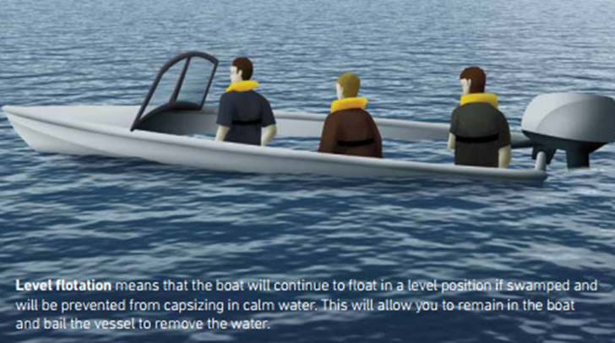

ABP breakdown
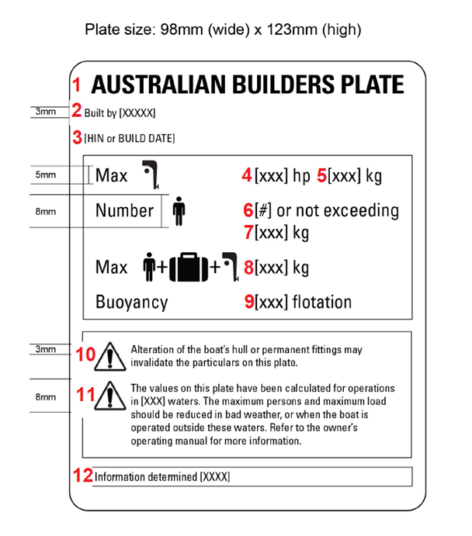
This is a sample of an ABP for a boat less than 6 meters with an outboard motor. For further details, please refer to the National Standard for Australian Builders Plate for Recreational boats.

- The title: AUSTRALIAN BUILDERS PLATE.

- The name of the boat builder (or importer/competent person), determined in compliance with the Standard and relevant legislation.

- The HIN or build date – when a HIN is present, it must be used.

- For boats with an outboard motor - The outboard engine power rating, as determined in compliance with the specified standard.

- For boats with an outboard motor - The maximum outboard engine mass for the boat as determined in compliance with the specified standard.

- The maximum number of persons for the boat as determined in compliance with the specified standard.

- The maximum total mass of persons for the boat as determined in compliance with the specified standard.

- The maximum load capacity for the boat (persons + motors + unallocated load for personal gear, etc), as determined in compliance with the specified standard.

- The buoyancy statement specifying whether the boat, as designed and tested, meets the requirements for either basic or level flotation. From ABP Standard Edition 5 onwards, when the specified standard requires that level flotation be fitted to the boat, the boat shall have level flotation fitted.

- The mandatory statement: “WARNING – Alteration of the boat’s hull or permanent fittings may invalidate the particulars on this plate”.

- The operating capacity warning statement/s (consistent with the specified standard) providing information to the consumer on any operational limitations, or reductions required, to the maximum load or maximum person capacity in different operating conditions.

- The name of the standard used to determine the information on the plate.

