Frequently asked questions-
Boat dealers
National Standard for the Australian Builders Plate for Recreational Boats - Edition 5

These frequently asked questions (FAQs) are provided to assist with the understanding of the Australian Builders Plate Standard – Edition 5 (the Standard) as endorsed in June 2020 and its application.

No guarantees are provided for the accuracy or currency of information contained in this document, nor does it constitute legal advice. It remains the responsibility of a person calculating, fitting or otherwise interacting with an Australian Builders Plate (ABP) to ensure they comply with relevant legislation.
Contents

Definitions 1
FAQ’s - Boat Dealers 2
Customer benefits 2
Selling boats with an ABP 2
Boats requiring an ABP 3
Fixing and approving ABP plates 4
Modifications to boats 5
Imported boats 6
Motors 7
Understanding the information on an ABP 8
Manufacturing standards 9
Flotation 9
ABP breakdown 11

Definitions

ABP – The Australian Builders Plate, which is affixed to recreational vessels as required by the National Standard for The Australian Builders Plate for Recreational Boats.

ABP Standard / the Standard / ABP Standard, Edition 5 (Edition 5) – The National Standard for The Australian Builders Plate for Recreational Boats endorsed by the Transport and Infrastructure Council on 5 June 2020, accessible here:
ABP Standard, Edition 4 (Edition 4) The National Standard for The Australian Builders Plate for Recreational Boats, published on 23 May, 2011 and superseded by Edition 5, accessible here:
ABYC – American Boat and Yacht Council.
ARBSC – The Australian Recreational Boating Safety Committee.
Boat builder – For the purposes of this document, reference to a ‘boat builder’ means a person who holds a responsibility to fix an ABP, unless otherwise specified.
CE – Conformité Européenne (certification marking).
Determining – The process of undertaking measurements, tests and calculations required to establish the information to be listed on an ABP.
HIN – Hull Identification Number.
NMMA – National Marine Manufacturers Association (United States).
Specified Standards / Specified Technical Standards – Documents that determine vessel build standards and associated calculations. These are the three referenced standards in the National Standard for The Australian Builders Plate for Recreational Boats. The specified standards referenced are the relevant Australian Standard (AS1799), American Boat and Yacht Council (ABYC) Standard and the International Organisation for Standardisation (ISO) Standards.

FAQ’s - Boat Dealers

Customer benefits

How will my customers benefit from the ABP?
The ABP provides customers with important safety information regarding a boat and helps them make informed decisions. The ABP conveys information including loading, capacity, maximum engine size, buoyancy and any other additional information the manufacturer wishes to provide.

This information helps customers pick the boat that’s right for their needs - from the number of people it can carry to the horsepower they require. Because the information on the ABP is uniform, customers can easily compare different types and models of boats, including imported boats.

These features help keep boaters safe on the water, improve trust in the quality of new vessels and promote safe, life-long boating.

Selling boats with an ABP

Can I sell a new boat without an ABP?
No.

Unless of course, it is exempt from ABP requirements (see “Boats requiring an ABP” below).

Can I sell second-hand boats without an ABP?
In general, yes.

Second-hand boats without an ABP, that have previously been registered in a state or territory, can still be sold. A boat that has never been registered or is newly imported may be treated like a new boat.

Refer to your local marine safety agency for more information.

Boats requiring an ABP

Which boats are required to have an ABP?
New powered recreational craft supplied in Australia, are required to have an ABP fitted unless subject to an exemption.

An ABP is not required on the following:
- aquatic toys
- amphibious vehicles
- canoes, kayaks and similar boats designed to be paddle-powered such as surf skis
- hydrofoils and hovercraft
- pedal powered boats
- personal watercraft intended to carry no more than two persons
- personal watercraft compliant with ISO 13590
- paddleboards
- racing boats
- rowing shells used for racing or rowing training
- sailboards
- sailing boats
- stand-up paddleboards
- submersibles
- surf row boats
- boats more than 24 m in length.

The exception for rowed or paddled craft applies only to those that, as designed and built, are incapable of being fitted with an outboard motor.

A sailing boat with an auxiliary engine is exempt from the requirement to have an ABP fitted.

The Standard applies to inflatable boats, except where the boat has a plate attached that complies with EU Directive 2013/53/EU–Recreational Craft Directive or NMMA requirements.

Personal watercraft intended to carry more than two persons must either comply with ABP requirements, or with ISO 13590, or have permanently marked information regarding the total mass of persons and equipment, and the total number of persons, the craft can carry.

Vessels subject to a Certificate of Survey (commercial vessels) have different requirements. Details may be obtained from your local Australian Maritime Safety Authority (AMSA) office.

The Trans-Tasman Mutual Recognition Act 1997 allows for the importation and sale of New Zealand built vessels into the Australian market, on the condition that the vessels comply with the requirements of the New Zealand market. It’s still desirable that New Zealand built vessels are affixed with an ABP when imported into Australia.

What labelling does a personal watercraft require?
An ABP is not required on a PWC designed to carry up to two people. An ABP is required on other PWCs unless the craft already has information clearly and permanently marked that states:
- the maximum number of persons the vessel may carry, as recommended by the builder
- the total mass of persons and equipment, expressed in kilograms, that the craft is designed to carry, as recommended by the builder.

Alternatively, a PWC may have a capacity label compliant with the requirements of ISO 13590.

What labelling does an inflatable boat require?
An inflatable boat requires an ABP - unless it already has a plate affixed in accordance with the EU Directive 2013/53/EU–Recreational Craft Directive, or a plate attached in accordance with the requirements of the US National Marine Manufacturers Association.

Fixing and approving ABP plates

Is the dealer responsible for fixing the ABP to the boat?
Typically, no.

However, boat dealers may be responsible for fitting an ABP if:
- the boat dealer is also the boat importer
- the boat dealer has modified or fitted accessories to the boat prior to its initial supply to a consumer. In this circumstance, the boat dealer must ensure the modifications have not invalidated the ABP values. If ABP values are invalidated, the modifications may still be possible if a new ABP is calculated and fitted.

Refer to your local marine safety agency for more information.

Who is responsible for affixing the ABP to the boat?
The ABP must be fitted by:
- the builder if the boat is built in Australia
- the importer if the boat is built outside Australia.

In either case, the person or company must be a legal entity in Australia and take responsibility for the accuracy of the information on the plate. The name of the person or company fitting the ABP to the boat is shown on the ABP.

If a boat dealer modifies a new boat prior to its initial supply to a customer in a way that invalidates the values on the ABP, they have assumed the responsibility of a boat builder.

Who can determine the information on an ABP?
The information on an ABP must be determined by a competent person.

A competent person is a person who has acquired through training, qualification, experience, or a combination of these, the knowledge and skills enabling that person to competently determine the information on an ABP.

The competent person is either:
- the builder
- the importer
- a third-party competent person.

In general, a commercial boat builder is deemed to be a competent person for the purpose of the ABP standard. In the case of an owner-builder or importer, they may not meet the definition of a competent person, in which case a third-party competent person should be engaged to determine the information. Where this occurs, the name of the third-party competent person should be shown on the ABP, along with that of the builder or importer.

Any person whose name appears on the plate is assuming responsibility for the information on that plate.

The Australian Recreational Boating Safety Committee encourages parties with ABP responsibilities to consider engaging the services of a qualified naval architect to assist with the calculation of ABP values.

How does the consumer know which of these people has supplied the information on the plate?
The person who is supplying the information on the plate needs to identify themselves by name and state the capacity in which they are providing the information. They must be a legal entity in Australia.

Examples:
- Built by Sunhope Boats, Australia
- Imported by RayStan Holdings, Australia
- Information approved by E.R. Smith, Naval Architect, Sydney, Aust.

Modifications to boats

If a boat is modified, does it require a new ABP?
Boat dealers have a responsibility to ensure that the boats they supply comply with applicable Standard requirements. If a dealer modifies a new boat so that the information on the plate is no longer correct, then the dealer will need to ensure that:
- the modification can be conducted in compliance with ABP Standard requirements; and-
- a new ABP is placed on the boat prior to sale, with values calculated by a competent person.

The dealer can request that this be done by the builder, if the builder is agreeable, or alternatively by another competent person.

Boat dealers should not modify a boat in a manner that cannot be supported by the Standard. Persons determining ABP values must comply with the requirements of the Standard when conducting their assessments. They may advise that some modifications/ABP changes are not possible.

This requirement may vary according to local legislation. Check with the local marine safety agency to confirm the regulations in your state or territory.

What level of modification requires a new ABP?
Any modification that invalidates the information on the existing plate requires a new plate to be fitted to the boat.

Examples:
- removing flotation chamber to install a live bait tank would alter the buoyancy of the craft and require the calculation of a new plate
- fitting accessories such as additional seats, fish boxes, extra or larger fuel tanks, extra batteries, would add mass to the boat and may exceed the allocated loading capacity of the boat, requiring the load capacities of the boat to be reduced.

It’s recommended that boat dealers liaise with boat manufacturers regarding modifications and optional accessories.

Can boat builders anticipate dealer modifications in their ABP calculations?
A boat builder, in compliance with ABP specified standards, may determine information on the plate to allow for “standard customisation options” that reflects normal purchaser demand. This provides scope for a dealer to ‘option up’ to that level without having to alter the ABP.

For example. Boat builders may incorporate the mass of a trolling motor and batteries into their ABP calculations, allowing a boat dealer to fit a trolling motor without invalidating listed ABP loading values. This would have to be confirmed with the person who determined the ABP values.

If modifications or customisation occurred outside the ‘standard customisation options’ a new ABP would probably be needed.

Imported boats
*For more information regarding the ABP and boat importation, please refer to FAQs – Boat Importers.

Do imported new boats that come into Australia with a NMMA or CE plate still require an ABP?
Typically, yes.

A foreign compliance plate is not considered a substitute for an ABP, except for inflatable vessels and personal watercraft as established in the Standard.

It’s noted that:
- CE plates don’t include all the information on an ABP (they have no flotation statement and no warning statement about modification)
- ABYC/NMMA plates have no flotation statement, no outboard mass, no build date, no warning statement and masses are typically listed in pounds not kgs
- ABPs allow consumers to easily compare boats like-for-like and make informed decisions.

Motors

If an outboard powered boat is sold without a motor, does the ABP have to include a maximum outboard engine power rating?
The Standard requires that all ABP sections are completed correctly. For boats intended to be powered by outboard engines, this includes the maximum outboard engine power rating and mass that the hull can safely handle. This allows the owner of the vessel to fit an appropriately sized motor later.

Does the power rating have to be in kilowatts?
No.

The ABP standard states that the maximum power capacity can be expressed in either horsepower (HP) or kilowatts (kW). The mass of the outboard motor must, however, be specified in kilograms.

What happens if an auxiliary (trolling/reserve) outboard is fitted to a new boat?
Auxiliary outboard power
An ABP’s maximum outboard power rating applies only to the boat’s primary motor(s). The power of any reserve/auxiliary outboard is excluded.

For example. If a boat’s ABP allows for a maximum outboard engine power rating of 50 HP, it may be fitted with a 50 HP motor and a 4 HP auxiliary motor.

Auxiliary outboard mass
The auxiliary motor mass, and associated masses such as additional batteries, must be considered when a boat operator assesses a boats load.

If a boat dealer fits an auxiliary motor to a new boat before its initial supply to a consumer, the boat dealer must ensure it does not exceed the maximum load capacity of the boat. If the auxiliary motor invalidates ABP values, a new ABP will be required.

Eg. A new boat has 500 kg of total maximum load listed on the ABP, comprised of:
+ 320kg of max person capacity (4 persons);
+ 120kg of max outboard motor mass; and
+ 60kg of “unallocated maximum load.”
= 500kg

A dealer then supplies this boat with a:
+ 120kg outboard motor; and
+ A trolling motor with batteries of 80kg mass;
= 200kg

If this boat was then operated with the person load listed on the ABP (+320kg), the total load on board would be:
+ 120kg outboard motor
+ 80kg trolling motor
+ 320kg persons
= 520kg (20kg over the 500kg ABP maximum load)

In this circumstance, a new ABP will be needed, if allowed by the specified standards, as the dealer has invalidated the ABP values. If the specified standards do not allow this change, then the dealer cannot conduct the modification.

If, for the same vessel, the dealer instead fits a 30 kg trolling motor, it will stay within the ABP guidance. The dealer should inform the purchaser that the maximum “carry-on/gear” load is reduced, but the dealer wouldn’t need to obtain a new ABP.

Understanding the information on an ABP

What’s included in the maximum load capacity?
The maximum load capacity represents the maximum mass a boat has been designed and tested to safely carry when underway, determined in accordance with the specified technical standard. This includes the mass of persons, the outboard, including any auxiliary outboard motor, portable fuel tanks, and carry on equipment such as personal equipment, personal safety equipment, spare parts, tools, dry provisions, fishing tackle, portable tanks and their contents and anything else carried on board.

It does not include the mass of the contents of fixed fuel and water tanks when full. These masses should be included in hull mass.

States may require boaters to comply with the maximum loading capacity listed on an ABP with or without modification. Check with your local marine safety agency to confirm the regulations in your state or territory.

What does the maximum persons capacity mean?
The maximum persons capacity is the recommended number of persons the boat can safely carry, based on mass, when operated within designated parameters, for example, protected waters and calm weather, or otherwise specified.

Boaters should never exceed the maximum kilogram mass of persons listed on an ABP.

States may require boaters to comply with the person capacity listed on an ABP (with or without modification). Check with your local marine safety agency to confirm the regulations in your state or territory.

Manufacturing standards

Do boats have to be constructed in compliance with technical standards?
The Standard requires that the information on an ABP complies with a specified technical standard and that flotation is fitted in accordance with the requirements of that specified standard.

The Standard does not require that boats are designed, constructed or certified against technical standards.

The ABP will only identify which standard has been used to determine the information provided on the plate. This does not mean that the boat complies with other aspects of that standard, such as fire protection and hull construction.

Regardless of the minimum legal requirements of the Standard, boat dealers are encouraged to sell craft that are fully certified against technical standards. Technical standards promote safety in relevant aspects of a boat’s design, provide an assurance of quality and selling point for consumers and may assist boat builders to address any liability questions that arise regarding the performance of their craft.

Flotation

What is meant by basic and level flotation?
The Standard defines basic flotation as “a flotation system that will keep a boat carrying its maximum load from sinking when swamped, assuming the occupants of the boat have left it and are in the water clinging to it. With basic flotation the swamped boat may float at any attitude.”

When determining ‘basic flotation’ buoyancy for a boat, the definition and performance requirement for basic flotation detailed in the specified standard must be used.

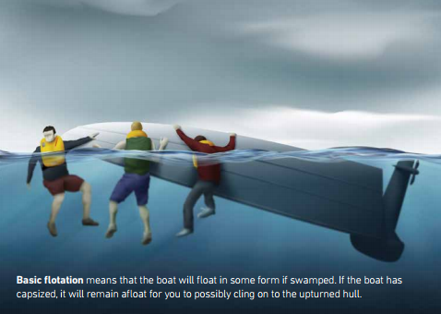

Level flotation is defined in the ABP standard as being “a flotation system that will keep a boat carrying its maximum load from sinking when swamped, assuming the occupants remain within the boat and supported by the flotation system. The flotation system must be such that it will keep the swamped boat floating level, and significantly reduce the likelihood of capsizing in calm water.”

Level flotation does not provide a self-righting capacity, but in calm water it should allow for self-rescue through the bailing of the boat. When compared with basic flotation, it provides a better place of refuge in the case of a marine incident, better access to safety equipment and a larger target for rescuers to spot.

Level flotation is a significantly better safety feature than basic flotation.

When determining ‘level flotation’ buoyancy for a boat, the definition and performance requirement for level flotation detailed in the specified standard must be used.

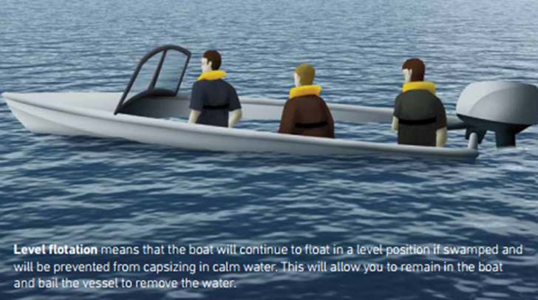

ABP breakdown
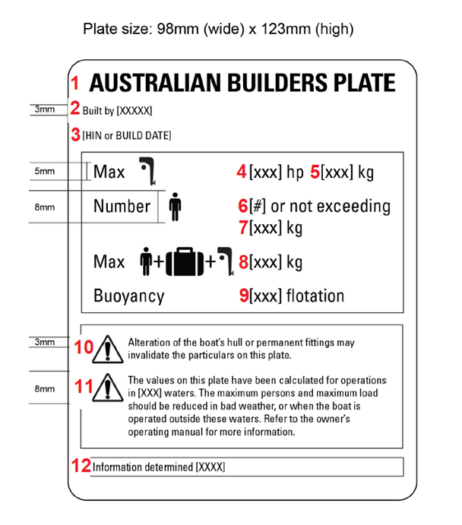
This is a sample of an ABP for a boat less than 6 meters with an outboard motor. For further details, please refer to the National Standard for Australian Builders Plate for Recreational boats.

- The title: AUSTRALIAN BUILDERS PLATE.

- The name of the boat builder (or importer/competent person), determined in compliance with the Standard and relevant legislation.

- The HIN or build date – when a HIN is present, it must be used.

- For boats with an outboard motor - the outboard engine power rating, as determined in compliance with the specified standard.

- For boats with an outboard motor - the maximum outboard engine mass for the boat as determined in compliance with the specified standard.

- The maximum number of persons for the boat as determined in compliance with the specified standard.

- The maximum total mass of persons for the boat as determined in compliance with the specified standard.

- The maximum load capacity for the boat (persons + motors + unallocated load for personal gear, etc), as determined in accordance with the specified standard.

- The buoyancy statement specifying whether the boat, as designed and tested, meets the requirements for either basic flotation or level flotation. From Edition 5 onwards, where the specified standard requires that level flotation be fitted to the boat, the boat shall have level flotation fitted.

- The mandatory statement: “WARNING – Alteration of the boat’s hull or permanent fittings may invalidate the particulars on this plate”.

- The operating capacity warning statement/s, consistent with the specified standard, providing information to the consumer about any operational limitations, or reductions required to the maximum load or maximum person capacity in different operating conditions.

- The name of the standard used to determine the information on the plate.

