Frequently asked questions-
Boat builders
National Standard for the Australian Builders Plate for Recreational Boats - Edition 5

These frequently asked questions (FAQs) are provided to assist with the understanding of the Australian Builders Plate Standard – Edition 5 (the Standard) as endorsed in June 2020 and its application.

No guarantees are provided for the accuracy or currency of information contained in this document, nor does it constitute legal advice. It remains the responsibility of a person calculating, fitting or otherwise interacting with an Australian Builders Plate (ABP) to ensure they comply with relevant legislation.
Contents

Definitions 1
FAQs - Boat Builders 2
Compliance and boats requiring an ABP 2
Responsibility to fit plates and determine information 4
ABP location and fixing 5
Plate design and construction 5
HIN numbers and the ABP 6
Symbols 6
Standard to be shown on an ABP 7
Maximum load and persons capacity 8
Motors 9
Flotation 10
ABP breakdown 11

Definitions

ABP – The Australian Builders Plate, which is affixed to recreational vessels as required by the National Standard for The Australian Builders Plate for Recreational Boats.

ABP Standard / the Standard / ABP Standard, Edition 5 (Edition 5) – The National Standard for The Australian Builders Plate for Recreational Boats endorsed by the Transport and Infrastructure Council on 5 June 2020, accessible here:
ABP Standard, Edition 4 (Edition 4) The National Standard for The Australian Builders Plate for Recreational Boats, published on 23 May, 2011 and superseded by Edition 5, accessible here:
ABYC – American Boat and Yacht Council.
ARBSC – The Australian Recreational Boating Safety Committee.
Boat builder – For the purposes of this document, reference to a ‘boat builder’ means a person who holds a responsibility to fix an ABP, unless otherwise specified.
CE – Conformité Européenne (certification marking).
Determining – The process of undertaking measurements, tests and calculations required to establish the information to be listed on an ABP.
HIN – Hull Identification Number.
NMMA – National Marine Manufacturers Association (United States).
Specified Standards / Specified Technical Standards – Documents that determine vessel build standards and associated calculations. These are the three referenced standards in the National Standard for The Australian Builders Plate for Recreational Boats. The specified standards referenced are the relevant Australian Standard (AS1799), American Boat and Yacht Council (ABYC) Standard and the International Organisation for Standardisation (ISO) Standards.

FAQs - Boat Builders

Compliance and boats requiring an ABP

Are the ABP requirements uniform around Australia?
All Australian states (and the NT) apply the Standard, either through maritime safety or consumer protection law. There are some differences between states in the mechanism for enforcing compliance as a result of local legislation; however, a boat that complies with the standard will meet the legal requirements around Australia.

Check with your local marine safety agency to confirm the regulations in your State or Territory.

Which boats are required to have an ABP?
New powered recreational craft supplied in Australia, are required to have an ABP fitted unless subject to an exemption.

An ABP is not required on the following:
- aquatic toys
- amphibious vehicles
- canoes, kayaks and similar boats designed to be paddle-powered such as surf skis
- hydrofoils and hovercraft
- pedal powered boats
- personal watercraft intended to carry no more than two persons
- personal watercraft compliant with ISO 13590
- paddleboards
- racing boats
- rowing shells used for racing or rowing training
- sailboards
- sailing boats
- stand-up paddleboards
- submersibles
- surf row boats
- boats more than 24 m in length.

The exception for rowed or paddled craft applies only to those that, as designed and built, are incapable of being fitted with an outboard motor.

A sailing boat with an auxiliary engine is exempt from the requirement to have an ABP fitted.

The Standard applies to inflatable boats, except where the boat has a plate attached that complies with EU Directive 2013/53/EU–Recreational Craft Directive or NMMA requirements.

Personal watercraft intended to carry more than two persons must either comply with ABP requirements, or with ISO 13590, or have permanently marked information regarding the total mass of persons and equipment, and the total number of persons, the craft can carry.

Vessels subject to a Certificate of Survey (commercial vessels) have different requirements. Details may be obtained from your local Australian Maritime Safety Authority (AMSA) office.

The Trans-Tasman Mutual Recognition Act 1997 allows for the importation and sale of New Zealand built vessels into the Australian market, on the condition that the vessels comply with the requirements of the New Zealand market. It’s still desirable that New Zealand built vessels are affixed with an ABP when imported into Australia.

What labelling does a personal watercraft require?
The ABP is not required on a PWC designed to carry up to two people.

An ABP is required on other PWCs unless the craft already has information clearly and permanently marked that states:
- the maximum number of persons the vessel may carry, as recommended by the builder
- the total mass of persons and equipment (expressed in kilogram’s) that the craft is designed to carry, as recommended by the builder.

Alternatively, a PWC may have a capacity label compliant with the requirements of ISO 13590.

What labelling does an inflatable boat require instead of an ABP?
An inflatable boat requires an ABP - unless it already has a plate affixed in accordance with EU Directive 2013/53/EU–Recreational Craft Directive, or a plate attached in accordance with the requirements of the US National Marine Manufacturers Association.

Responsibility to fit plates and determine information

Who is responsible for affixing the ABP to the boat?
The ABP must be fitted by:
- The builder if the boat is built in Australia; or
- The importer if the boat is built outside Australia.

In either case, the person or company must be a legal entity in Australia that takes responsibility for the accuracy of the information on the plate. The name of the person or company fitting the ABP to the boat is shown on the ABP.

If a boat dealer modifies a new boat prior to its initial supply to a customer in a way that invalidates the values on the ABP, they have assumed the responsibility of a boat builder and must ensure a new ABP is fitted.

Who can determine the information on an ABP?
The information on an ABP must be determined by a competent person.

A competent person is defined as a person who has acquired through training, qualification, experience, or a combination of these, the knowledge and skills enabling that person to competently determine the information on an ABP.

The competent person is either:

- the builder;
- the importer; or
- a third-party competent person.

In general, a commercial boat builder is deemed to be a competent person for the purpose of the ABP standard. In the case of an owner-builder or importer, they may not meet the definition of a competent person, in which case a third-party competent person should be engaged to determine the information. When this occurs, the name of the third-party competent person should be shown on the ABP, along with that of the builder or importer.

Any person whose name appears on the plate is assuming responsibility for the information on that plate.

Examples:

- Built by Sunhope Boats, Australia
- Imported by RayStan Holdings, Australia
- Information approved by E.R. Smith, Naval Architect, Sydney, Aust.

The Australian Recreational Boating Safety Committee encourages parties with ABP responsibilities to consider engaging the services of a qualified naval architect to assist with the calculation of ABP values.

ABP location and fixing

Where is the ABP fitted to a boat?
The ABP must be placed in a position where it will be readily visible to the operator of the boat when getting the boat underway, preferably in the cockpit or near the steering position. Placing the ABP on the outside of the transom of a boat is not acceptable.

How is the plate fixed to the boat?
The plate must be permanently fixed to the boat so that is resistant to removal without leaving some obvious mark.

Examples of ways in which a plate might be attached include riveting, gluing, embedding, engraving or printing the plate directly onto the boat, provided that whatever method is used, the plate is permanently fixed to the boat.

For boats with more than one steering position, do I need to put an ABP at each steering location?
The Standard introduced the requirement for boats with a flybridge to fix a second, identical ABP at the flybridge steering position. Boats with a flybridge must also include a maximum person capacity for the flybridge on their ABP.

There’s no requirement for boats without a flybridge to display multiple ABPs. Boat builders are encouraged to consider fitting multiple ABPs where, because of a boats design, it may promote better safety outcomes.

Plate design and construction

Has the appearance of the ABP changed over time?
Yes. The Standard changed the way person capacity on a builders plate is described.

ABPs compliant with editions 1 to 4 of the Standard display person capacity as: “Max Person: ## = XXXkg”. ABPs compliant with edition 5 display person capacity as “Number Person: ## or not exceeding XXXkg”.

Edition 5 also introduced the inclusion of an ‘area of operation’ warning statement on an ABP as a mandatory requirement.

Does the plate have to be made of metal?
No.

The Standard does not specify the construction material of the plate. However, it does establish that the information on a plate must be capable of withstanding the combined effects of water, oil, salt spray, direct sunlight, heat, cold and wear expected in the normal operation of the boat, without loss of legibility. The ABP must also be resistant to alteration of information.

Does the plate have to be a particular shape or size?
No.

The plate can be any size and shape provided it complies with the requirements relating to text, symbol size and legibility, and displays all the information required by the Standard. The Standard provides a sample plate that meets its requirements to assist manufacturers to design their own plate.

Can I use the same plate template for boats less than six metres, and boats six metres or more in length?
The Standard requires boats less than six metres in length to have additional buoyancy fitted and stated.

Boats that are six metres or more in length are not required to state their buoyancy; however, they may elect to do so.

In principal the more onerous plate, the one for vessels under 6m, could be used on all vessels, however it may be simpler to use different plates.

HIN numbers and the ABP

Do I have to put a HIN on the ABP?
Either a HIN or a build year must be shown on the boat’s ABP.

The Standard introduced the requirement that when a boat has a HIN attached prior to the issue of an ABP, that HIN must also be listed on the ABP.

Most local builders place HINs on all their boats, allowing them to be sold anywhere in Australia.

If a boat has a HIN, does it also need an ABP?
Yes.

The HIN and the ABP serve different purposes and provide different information. The requirement to put an ABP on a boat is in addition to any existing requirements relating to HINs.

If a HIN is required, it should still be placed on the boat in the places required by the HIN system. Placing the HIN on the ABP does not replace the requirement to mark the HIN elsewhere on the boat. The HIN on the ABP effectively becomes the third recording of the HIN and is used as a means of readily identifying the build date of the boat.

Symbols

Which symbols are used on the ABP?
Symbols that may be used include an outboard engine symbol, a person symbol, a suitcase symbol and a warning symbol.

If symbols are used:

- The outboard engine symbol shall be used to display information about a boat’s maximum outboard power capacity and mass.
- The person symbol shall be used to display information about a boat’s maximum person capacity as the number of adults and their total mass.
- The person symbol combined with the suitcase and outboard symbols (in the case of a boat not fitted with an inboard engine) shall be used to display the boat’s maximum load capacity.
- The warning symbol shall be used to display warning information.

Standard to be shown on an ABP

Does an ABP have to show the specified standard used to determine the information provided on the plate?
Yes.

The name of the specified standard must be shown on the plate. This should be expressed as: “Information determined (insert name of appropriate standard)”.

The name of the standard may be expressed as the standard number or abbreviation by which the standard is commonly known, rather than its title (i.e.: AS 1799, ISO, ABYC). Example: “Information determined - AS 1799.”

*NOTE-
The requirement that information must be determined from a specified standard does not imply the boat has been manufactured to that standard.

Do I need to use the same standard to determine all the information on the plate?
Yes.

A single standard system must be used to determine all the items of information on a plate (eg. buoyancy performance, the load/persons capacity and the maximum outboard power). Builders cannot ‘mix-and-match’ standard systems on individual vessels.

The standard system may be either ABYC, AS1799 or ISO.

Do boats have to be constructed in compliance with technical standards?
The Standard requires that the information on an ABP is determined in compliance with a specified technical standard, and that flotation is fitted in accordance with the requirements of that standard. The Standard does not require that boats are designed, constructed or certified against technical standards.

The ABP will only identify which standard has been used to determine the information provided on the plate. This does not mean that the boat complies with other aspects of that standard, such as fire protection and hull construction.

Regardless of the minimum legal requirements of the Standard, boat builders should always consider certifying their boats against technical standards. Technical standards promote safety in relevant aspects of a boats design and provide an assurance of quality and selling point for consumers. The determination of ABP values should be simpler for a boat designed in accordance with a specified standard.

Technical standards may assist boat builders to address any liability questions that arise regarding the performance of their craft, especially following a boating accident.

Why doesn’t the Standard just specify one technical standard?
It is easier to import and export of boats when the technical standard in not specified, noting that many external markets require boats to be constructed to relevant national or international standards.

Australian boat builders are able to choose a technical standard that best works for them and their boats.

Which specified standard should I choose?
Each specified standard system has benefits and disadvantages. Boat builders are encouraged to investigate which standard best suits their business.

All standard systems deliver comparable results in respect to loading values and powering, although they determine these values through different methods.

Some factors to consider when choosing a technical standard include:
- the requirement to fit flotation as specified by the standard (ABYC and ISO typically require level flotation)
- whether boats will be exported
- the support arrangements available for each standard.

Maximum load and persons capacity

What is included in the maximum load capacity?
The maximum load capacity represents the maximum mass a boat has been designed and tested to safely carry when underway, determined in accordance with the specified technical standard. This includes the mass of persons, the outboard, including any auxiliary outboard motor, portable fuel tanks, and carry on equipment such as personal equipment, safety equipment, spare parts, tools, dry provisions, fishing tackle, portable tanks and their contents and anything else carried on board.

It does not include the mass of the contents of fixed fuel and water tanks when full as these masses should be included in hull mass.

States may require boaters to comply with the maximum loading capacity listed on an ABP (with or without modification). Check with the local marine safety agency to confirm the regulations in your state or territory.

What does the maximum persons capacity mean?
The maximum persons capacity is the recommended number of persons the boat can safely carry, based on mass, when operated within designated parameters, for example, protected waters and calm weather, or as otherwise specified.

Boaters should never exceed the maximum kilogram mass of persons listed on an ABP.

States may require boaters to comply with the person capacity listed on an ABP (with or without modification). Check with the local marine safety agency to confirm the regulations in your state or territory.

The specified technical standards used to calculate maximum load capacity (the Australian Standard, the ABYC standards and the ISO standards) all give similar results for total person mass capacity for a given boat. However, the standards each use different average person masses to calculate person numbers.

The Australian Standard (AS1799 – 2009) calculates adult mass at 80kg, with a minimum allowance of 10kg per person for ‘carry-on’ load, such as clothes, food and tackle.

The ABYC (USA) Standards uses a person mass (a mix of adults and children, rather than just adults) to arrive at an average mass of around 65kg.

The ISO (European) Standards utilise an average mass of 75kg per person.

Motors

If an outboard powered boat is sold without a motor, does the ABP have to include a maximum outboard engine power rating?
The Standard requires that all ABP sections are completed correctly. For boats intended to be powered by outboard engines, this includes the maximum outboard engine power rating and mass that the hull can safely handle. This allows the owner of the vessel to fit an appropriately sized motor later.

Does the power rating have to be in kilowatts?
No.

The Standard states that the maximum power capacity can be expressed in either horsepower (HP) or kilowatts (kW). The mass of the outboard motor must, however, be specified in kilograms.

What happens if an auxiliary (trolling/reserve) outboard is fitted to a boat?
The information about the maximum outboard motor power rating applies only to the boat’s primary motor. The power of any reserve outboard is excluded. However, the mass of the auxiliary motor would need to be counted when the owner assesses whether the proposed loading is within the maximum load capacity of the boat.

If a boat builder or dealer fits an auxiliary motor to a boat before its initial supply to a consumer, they will need to ensure it does not exceed the maximum load capacity of the boat.

Flotation

What’s meant by basic and level flotation?
The Standard defines basic flotation as “a flotation system that will keep a boat carrying its maximum load from sinking when swamped, assuming the occupants of the boat have left it and are in the water clinging to it. With basic flotation the swamped boat may float at any attitude.”

When determining ‘basic flotation’ buoyancy for a boat, the definition and performance requirement for basic flotation detailed in the specified standard must be used.

Level flotation is defined in the Standard as being “a flotation system that will keep a boat carrying its maximum load from sinking when swamped, assuming the occupants remain within the boat and supported by the flotation system. The flotation system must be such that it will keep the swamped boat floating level, and significantly reduce the likelihood of capsizing in calm water.”

Level flotation does not provide a self-righting capacity, but in calm water it should allow for self-rescue through the bailing of the boat. When compared with basic flotation, it provides a better place of refuge in the case of a marine incident, better access to safety equipment and a larger target for rescuers to spot.

Level flotation is a significantly better safety feature than basic flotation.

When determining ‘level flotation’ buoyancy for a boat, the definition and performance requirement for level flotation detailed in the specified standard must be used.
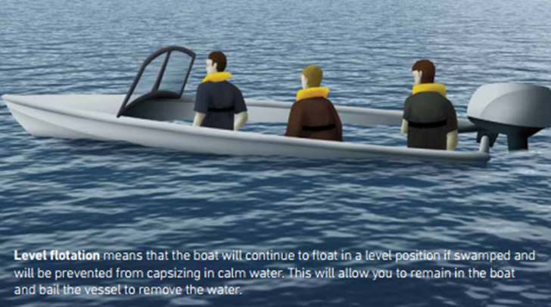

ABP breakdown
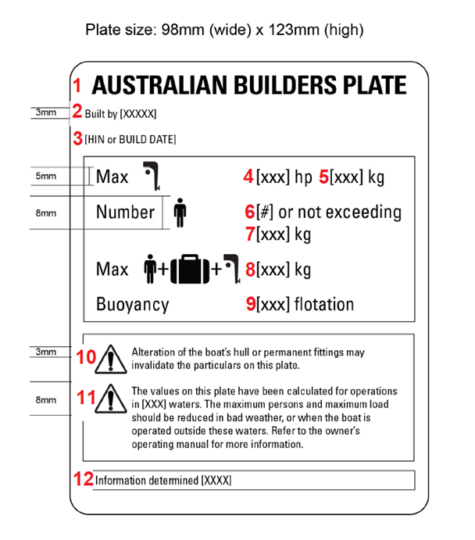
This is a sample of an ABP for a boat less than 6 meters with an outboard motor. For further details, please refer to the National Standard for Australian Builders Plate for Recreational boats.

- The title: AUSTRALIAN BUILDERS PLATE.

- The name of the boat builder (or importer/competent person), determined in compliance with the Standard and relevant legislation.

- The HIN or build date – when a HIN is present, it must be used.

- For boats with an outboard motor - The outboard engine power rating, as determined in compliance with the specified standard.

- For boats with an outboard motor - The maximum outboard engine mass for the boat as determined in compliance with the specified standard.

- The maximum number of persons for the boat as determined in compliance with the specified standard.

- The maximum total mass of persons for the boat as determined in compliance with the specified standard.

- The maximum load capacity for the boat (persons plus motors plus unallocated load for personal gear, and anything else carried on board), as determined in accordance with the specified standard.

- The buoyancy statement specifying whether the boat, as designed and tested, meets the requirements for either basic flotation or level flotation. From ABP Standard Edition 5 onwards, where the specified standard requires that level flotation be fitted to the boat, the boat shall have level flotation fitted.

- The mandatory statement: “WARNING – Alteration of the boat’s hull or permanent fittings may invalidate the particulars on this plate.”

- The operating capacity warning statement/s (consistent with the specified standard) providing information to the consumer about any operational limitations, or reductions required, to the maximum load or maximum person capacity in different operating conditions.

- The name of the standard used to determine the information on the plate.

